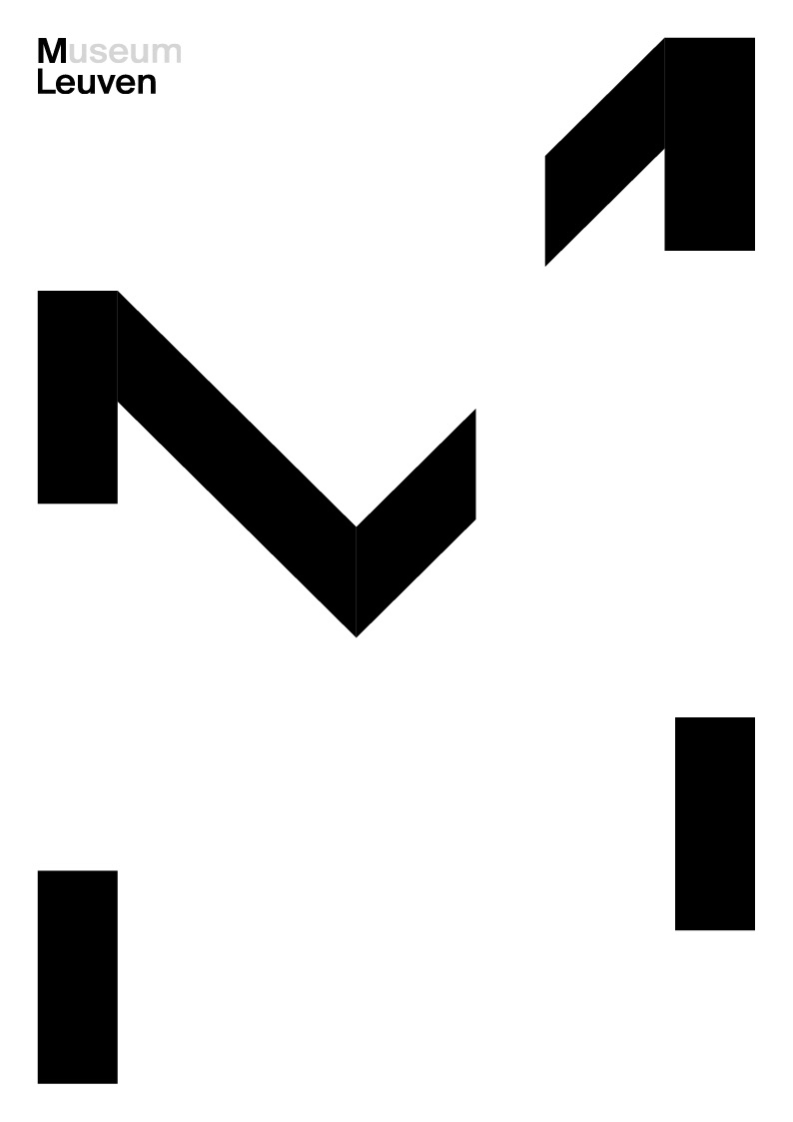

**Sigefride Bruna Hautman**

**Information on selected works**

**‘Moonproject 1: Rumours’ (1981)**

polyester, iron, wood, plastic, acrylic

Inspired by David Bowie

*"Don’t be afraid of the man in the moon, because it’s only me."*

Hautman’s *Moonproject* (1981) was inspired by this line from David Bowie’s song *Love You Till Tuesday* (1967). As a Bowie fan, Hautman has brought the so-called man in the moon to life through a unique blend of text and image. The sculptures in this project serve as both literal and figurative supports for the text.

The exhibition showcases five of the six original pieces in the *Moonproject*. The organic forms are inspired by texts that, like the phases of the moon, symbolize the cycles of nature and the recurring themes of life, growth and transformation in Hautman’s work. Hautman herself describes the series as “linguistic”. In her other textual works, she writes in English, a language in which she feels less at ease than in Dutch. This enables her to write directly and without inhibition.

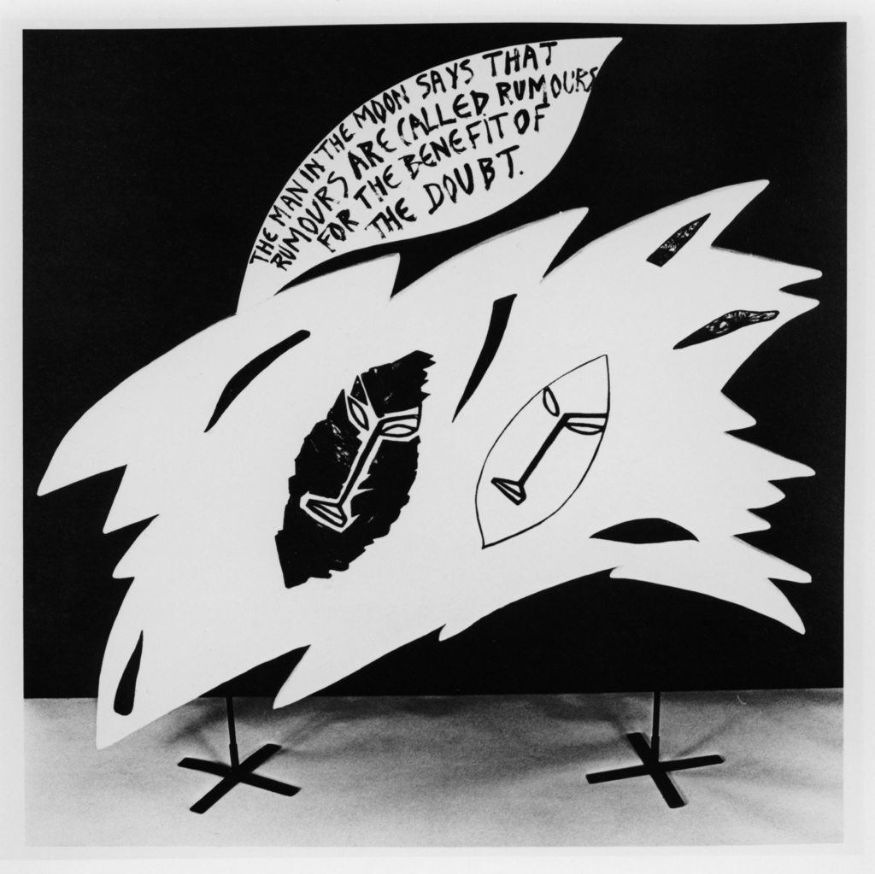The *Moonproject* is a continuation of the textual works that Hautman created in 1977 and 1978 within the experimental space ‘Today’s Place’, located in the Coppenolstraat, a side street off Antwerp’s Wolstraat. This was also a squat, functioning as an artist’s collective. There, Hautman, along with her husband, Narcisse Tordoir, took part in performances, exhibitions, actions, and parties. Archival materials related to‘Today’s Place’ are currently on display at M HKA.

‘Moonproject1: Rumours’, Sigefride Bruna Hautman,1981, photo: Luc Wauman

**‘Institutionalized Dignity’ (1982, 2025)**

Polyester, leather, iron, wood, acrylic

Renewed topicality

In this installation, two leather figures sit beneath an eagle’s all-seeing gaze; they are hunched over a table. The eagle, a symbol of freedom, power and dignity, also represents a wide range of ideologies. The piece raises questions about society’s compulsion to conform to obligatory social norms. Despite appearing to have been created specifically for these tumultuous times, the piece actually dates back to 1982. After being severely damaged by a fire, Hautman meticulously rebuilt the work for this retrospective.

Hautman trained at the Antwerp Art Academy, which emphasized classical sculpture and traditional craft techniques. At the time, artists were expected to use only one type of material per sculpture. Hautman broke with this tradition immediately upon graduating and has made multimedia works ever since. This installation, an early example of this approach, combines polyester with pigment, leather (cowhide), and painted MDF.

‘Institutionalized Dignity’, Sigefride Bruna Hautman, 1982, photo: Luc Wauman

**‘Portret 1 (Father)’ (1990)**

MDF, copper, glass, plaster, acrylic

Radical and metaphysical

This symbolic portrait of Hautman’s father is the first in a series of family portraits that she created in 1990. The sculpture is composed of elements that evoke his life and personality, such as the shipyard in Temse (represented by a bridge, a glass bottle with a tiny ship inside, etc.), where he worked for his entire career.

It is a noticeably radical composition. Hautman had previously created works featuring intricate decoration and ornamentation. In the early 1990s, however, she shifted toward a more avant-garde approach inspired by the early 20th-century art movement known as Metaphysical Painting. The associated artists strove to capture the mysterious and poetic essence of objects by detaching them from their traditional settings. Isolated and removed from their conventional context, the objects acquire new meanings: they become mythical, transcending their initial function. Hautman’s work from this period features simple, pure forms and a neutral colour palette. Each element is essential.

Hautman did not only portray her father in sculpture form. In the early 2000s, she began experimenting with video. The immediacy of this medium fascinated her, as it contrasted sharply with the long production time of her sculptures. She taught herself how to use the camera and created this two-channel video. Opposing screens in the exhibition show her father performing various tasks in the parental home in Bornem. Unlike the white, sculpted portrait from ten years ago, the video is colourful. This was a deliberate choice, befitting the memory of her father, whom she recalls as a vibrant personality. Images, texts, and music interact in this work to create a nuanced portrait.

**‘**Portrait 1 (Father)’, Sigefride Bruna Hautman, 1990, Collection M HKA/

Collection Flemish Community, photo: Dirk Gysels

**‘Portrait 5 (Yvon)’ (1990)**

Wood, plaster, acrylic

The parental journey

This work consists of two pitchers and two beakers, pouring liquid into each other, captured in a frozen moment. This artwork symbolizes the responsibility of parenthood and the invariably delicate balancing act of raising a child: an ongoing journey of self-discovery as a parent and for the values you want to instil in your child.

This is Hautman’s third portrait of her son Yvon. In 1986, she created a work entitled *Yvon*, consisting of four delicate, small, white sculptures.

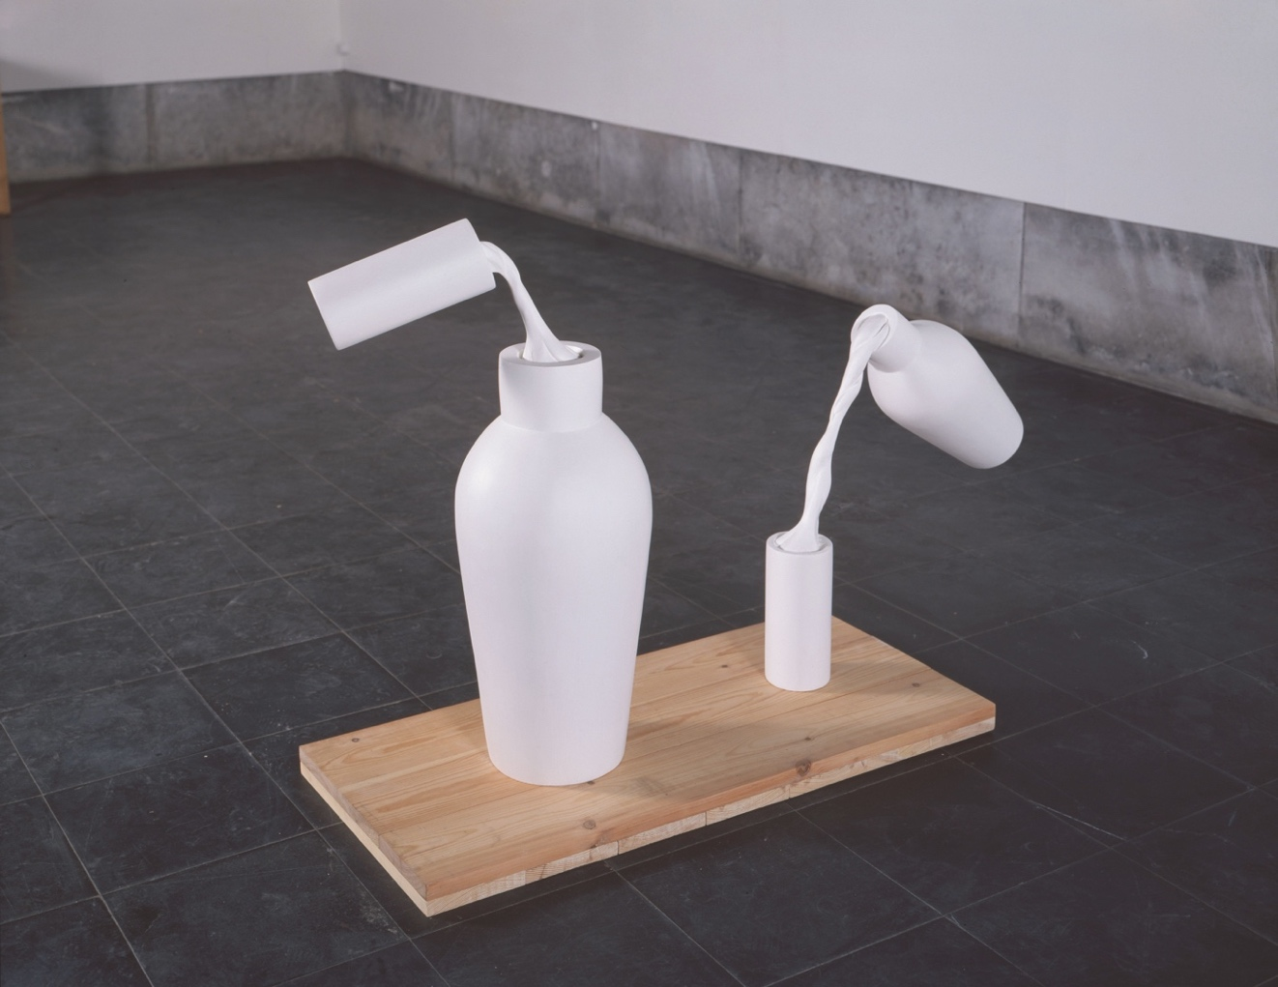In 1990, Hautman created two new portraits of her son, including the aforementioned work and an abstracted cot with a copper blanket. The form recalls a childhood drawing by Yvon, in which he sketched a small bed in front of a tree. The hollow section, made of red copper, represents the passage of life through thework.

‘Portrait 5 (Yvon 2)’, Sigefride Bruna Hautman, 1990, photo: Dirk Gysels

**‘Dying Wave’ (1984)**

plaster, zinc, acrylic

The eternal movement of ebb and flow

At the heart of *Dying Wave* is a bust of an enigmatic figure with a blue mask and a semi-blue hollow in the chest. For Hautman, blue represents introversion, a trait with which she personally identifies. The white relief in the background depicts a figure, possibly a woman, submerged in water. She appears to be embracing the waves, but perhaps she’s drowning. The title, *Dying Wave,* only adds to the ambiguity.

As one of two sculptures Hautman made in 1984 as metaphors for ebb and flow, or life and death, it is a uniquely symbolic work. The second sculpture, *Rising Wave (In the Realm of Petrified Thought, a Message Is Never in a Bottle)*, was lost. For all its austerity, *Dying Wave* is replete with complex symbolism.

In the 1980s, Hautman experimented with creating sculptures that represent water. She viewed this as a plastic challenge: how do you represent a fundamentally fluid, dynamic substance like water in the static medium of sculpture? At the same time, she explored its symbolic power, which can be a source of life and transformation, but also an elusive force of destruction and death.

Afbeelding met muur, overdekt, grond, vloer

Door AI gegenereerde inhoud is mogelijk onjuist.

‘Dying Wave’, Sigefride Bruna Hautman, Collection Mu.ZEE Ostend – Flemish Community, 1983, photo: courtesy of the artist

**‘Voile’ (2024)**

copper, textiles, plaster, clay, dibond, wood

Form explores the edge of thought

In the early 2000s, Sigefride Bruna Hautman embarked on a large-scale and ambitious project: *Hinkelpark*. This multimedia undertaking aims to delve into her past, analyse her journey to date, and explore her future. The project includes videos, animations and sculptures and is constantly evolving; it is a work in progress.

The installation *Voile* is a physical translation of the opening scene of *Hinkelpark*. A mask hangs at its centre, surrounded by dozens of colourful threads that stretch in every direction. This burst of colour and energy is accompanied by three enigmatic figures, frozen memories moving through the labyrinth’s lines. They represent the past and are waiting to begin their journey. The veil, or voile, carries an intriguing message along the embroidered border: *‘*Form explores the edge of thought.’

Afbeelding met muur, overdekt, kunst

Door AI gegenereerde inhoud is mogelijk onjuist.

‘Voile’, Sigefride Bruna Hautman, 2042, photo: Ronald Stoops

**‘Since I know, you cannot sit on a cloud’ (1986)**

wood, plaster, leather, metal

An invitation to talk

In the late 1970s and early 1980s, Sigefride Bruna Hautman deliberately sought interaction with the public in her work. When her sculptures were first exhibited at the Plus-Kern gallery in Brussels in 1986, visitors were encouraged to sit in the chairs and engage in conversation. While such interaction is not feasible in this exhibition, the small plaster reliefs stored on one of the sculptures’ shelves still serve as a prompt for contemplation and discourse.

This work is part of a set of three sculptures. Each one consists of two complementary parts. Only this pair has survived. Originally, all sculptures were on wheels, making them easy to manoeuvre around the exhibition space. The use of black and white highlights the graphic elements of the abstract designs, such as circles, triangles and squares.Hautman himself describes her work as “an abstract grid; a search for an essence”. With their minimalist design and unrestrained mobility, the sculptures allow for constant reinterpretation, not only by the artist but also by viewers.

‘Since I know, you cannot sit on a cloud’, Sigefride Bruna Hautman, 1986,

Collection M HKA - Flemish Community